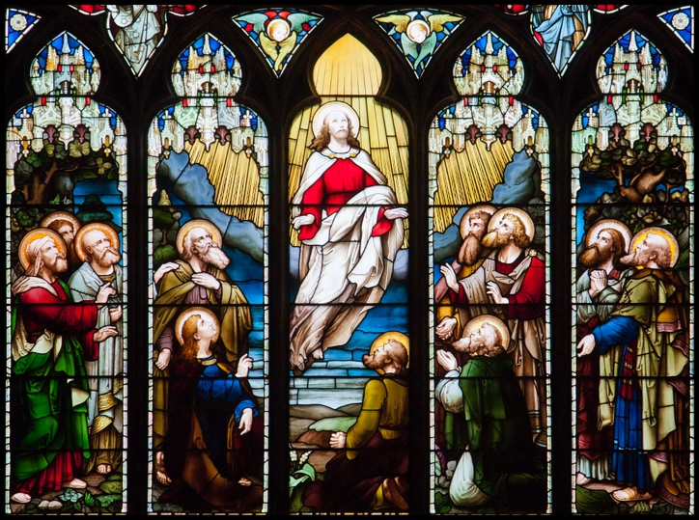 | Morning Worship  May 2022  Ascension – Ending and starting. Promises and patience.

Introduction and welcome
We are celebrating Ascension Day today, the day that Jesus went up to Heaven, even though it doesn’t actually occur until this coming Thursday. Normally, we don’t celebrate it at St. Nicholas’ so we thought we would take this opportunity to celebrate it today, with the underlying theme being ‘Endings and beginnings, patience and promises’. Ascension Day is an ending, with Christ’s final encounter with the disciples and his promise to them, but for the disciples it is also the start. Before then though, the disciples must be patient.

Opening Prayer:
Loving Lord,
Fill us with your life-giving,
joy-giving, peace-giving presence,
that we may praise you now with our lips and all the day long with our lives,
through Jesus Christ our Lord.
Amen.

Reading – Luke 24.44-53
⁴⁴ Then he said, “When I was with you before, I told you that everything written about me in the law of Moses and the prophets and in the Psalms must be fulfilled.” ⁴⁵ Then he opened their minds to understand the Scriptures. ⁴⁶ And he said, “Yes, it was written long ago that the Messiah would suffer and die and rise from the dead on the third day. ⁴⁷ It was also written that this message would be proclaimed in the authority of his name to all the nations, beginning in Jerusalem: ‘There is forgiveness of sins for all who repent.’ ⁴⁸ You are witnesses of all these things.
⁴⁹ “And now I will send the Holy Spirit, just as my Father promised. But stay here in the city until the Holy Spirit comes and fills you with power from heaven.”
⁵⁰ Then Jesus led them to Bethany, and lifting his hands to heaven, he blessed them. ⁵¹ While he was blessing them, he left them and was taken up to heaven. ⁵² So they worshiped him and then returned to Jerusalem filled with great joy. ⁵³ And they spent all of their time in the Temple, praising God.

Reading – Acts 1.1-11
1 In my first book I told you, Theophilus, about everything Jesus began to do and teach ² until the day he was taken up to heaven after giving his chosen apostles further instructions through the Holy Spirit. ³ During the forty days after he suffered and died, he appeared to the apostles from time to time, and he proved to them in many ways that he was actually alive. And he talked to them about the Kingdom of God.
⁴ Once when he was eating with them, he commanded them, “Do not leave Jerusalem until the Father sends you the gift he promised, as I told you before. ⁵ John baptized with water, but in just a few days you will be baptized with the Holy Spirit.”
⁶ So when the apostles were with Jesus, they kept asking him, “Lord, has the time come for you to free Israel and restore our kingdom?”
⁷ He replied, “The Father alone has the authority to set those dates and times, and they are not for you to know. ⁸ But you will receive power when the Holy Spirit comes upon you. And you will be my witnesses, telling people about me everywhere—in Jerusalem, throughout Judea, in Samaria, and to the ends of the earth.”
⁹ After saying this, he was taken up into a cloud while they were watching, and they could no longer see him. ¹⁰ As they strained to see him rising into heaven, two white-robed men suddenly stood among them. ¹¹ “Men of Galilee,” they said, “why are you standing here staring into heaven? Jesus has been taken from you into heaven, but someday he will return from heaven in the same way you saw him go!”

Reading – Ephesians 1.15-23
¹⁵ Ever since I first heard of your strong faith in the Lord Jesus and your love for God’s people everywhere, ¹⁶ I have not stopped thanking God for you. I pray for you constantly, ¹⁷ asking God, the glorious Father of our Lord Jesus Christ, to give you spiritual wisdom and insight so that you might grow in your knowledge of God. ¹⁸ I pray that your hearts will be flooded with light so that you can understand the confident hope he has given to those he called—his holy people who are his rich and glorious inheritance.
¹⁹ I also pray that you will understand the incredible greatness of God’s power for us who believe him. This is the same mighty power ²⁰ that raised Christ from the dead and seated him in the place of honour at God’s right hand in the heavenly realms. ²¹ Now he is far above any ruler or authority or power or leader or anything else—not only in this world but also in the world to come. ²² God has put all things under the authority of Christ and has made him head over all things for the benefit of the church. ²³ And the church is his body; it is made full and complete by Christ, who fills all things everywhere with himself.

Reflection
In the readings from both Luke and Acts, that we heard earlier, we have Jesus talking to his disciples and reaffirming all he had told them about himself, during the three years they had been together. Jesus then leaves them and ascends to Heaven to be with his Father, leaving them behind. Jesus has gone!
Jesus had left the disciples when he was crucified. There was a sense of loss and fear. But after resurrection, the disciples encountered Jesus who spoke to them and started to prepare them for their future mission. The scriptures and his teachings started to make more sense.
After Jesus’ ascension the disciples were alone again but there was no sense of loss or fear. They returned to Jerusalem filled with great joy of the promise that Jesus had given them. What a transformation!
That could have been the end of the story, and to some extent it was. Jesus had gone. But it may have been the end of one chapter of their lives, but it was just about to be the beginning of a ‘new story’. Before this new life could begin though, it was now a time of waiting, a time of anticipation, possibly a time of apprehension, but a time for patience. As they waited, they pondered. “What is this ‘Holy Spirit’, this ‘Power’ that Jesus had said was going to be given to them? What would it mean for them?”
The next part of their story doesn’t happen until later, at Pentecost, and we see it transform their lives, and ultimately ours too, forever.
The experience of the disciples at the ascension reminds us that we often say goodbye to things and people that have gone but then experience the joy of renewal and rebirth in preparation for new adventures that eventually follow as a new direction becomes clearer. In his letter to the Ephesians, Paul says “I pray for you constantly, asking God, the glorious Father of our Lord Jesus Christ, to give you spiritual wisdom and insight, so that you may grow in your knowledge of God.” We all need to have these episodes of ‘ending and then starting again’ so that, in our times of waiting, we may have time to seek out God and trust in Him as He knows what is best for us.
Jesus said to the disciples “The Father alone has the authority to set those dates and times, and they are not for you to know!” We are to be patient, and when the time is right, a new chapter WILL open up for us – a new story with God at the centre of it, and with his power and Holy Spirit within us, who knows what we can achieve. Amen.

Prayers
God of all, in Jesus Christ you give living water for the thirsty, bread of life for the hungry, the shelter of your wings for the fearful.
Lord Jesus Christ, we pray that your life changing message will reach everywhere where there is conflict suffering and poverty.
Christ, be our light. Christ, be our warmth. Christ, be our guide. Shine through the darkness. Always be our light, our warmth, our guide.
Lord Jesus Christ, at this time when there are so many challenges in the world, in nations and in our communities, let us hear your voice guide us.
Let whatever is ugly in us become small. Let whatever is beautiful become large. Let our fears become small. Let our confidence in you become large. Shrink our pride; enlarge our humility. Shrink our envy; enlarge our gratitude.
Let Your presence in our hearts rise up this Ascension time.
Amen.

The Lord’s Prayer:
Our Father in heaven, hallowed be your name.
Your Kingdom come, your will be done, on earth as in heaven.
Give us today our daily bread.
Forgive us our sins, as we forgive those who sin against us.
Lead us not into temptation but deliver us from evil.
For the kingdom, the power and the glory are yours.
Now and for ever. Amen

Closing prayer:
God of power,
may the boldness of your Spirit transform us,
may the gentleness of your Spirit lead us,
may the gifts of your Spirit equip us to serve and worship you
now and always.
Amen

Grace:
May the grace of our Lord Jesus Christ,
And the love of God,
And the fellowship of the Holy Spirit be with us all, now and evermore.
Amen.

