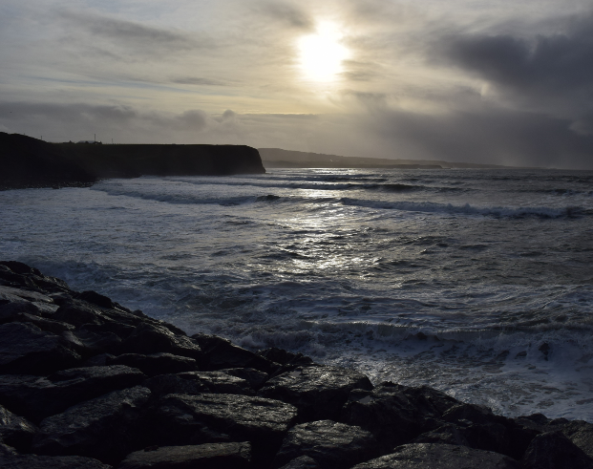 | Morning Worship  July 2020  “Joys and sorrows of Lockdown – and the future ahead”

We will share the readings and prayers together on Facebook Livestream at 10am on Sunday but we also invite you to use the readings, reflections and prayers as part of a time of contemplation. Find a quiet place to sit inside or outside to do this.
We look forward to the time when we will all be back together in person.
Ruth, Margaret, Mike and Nigel.

PRAYER OF APPROACH
We approach God now as children.
Resting in God’s presence.
Held in God’s love.
Waiting on God’s voice.
Comforting God, speak to us.
Amen.

OPENING PRAYER
Father God,
The light of your truth guides us to the way of Christ.
May all who follow Him find rest.
We ask this through our Lord Jesus Christ, Your Son.
Who lives and reigns with You and the Holy Spirit.
One God.
Now and forever. Amen.

READING – Matthew 11:16-19 & 25-30 New International Version (NIV)
¹⁶ “To what can I compare this generation? They are like children sitting in the marketplaces and calling out to others:
¹⁷ “‘We played the pipe for you,
and you did not dance;
we sang a dirge,
and you did not mourn.’
¹⁸ For John came neither eating nor drinking, and they say, ‘He has a demon.’ ¹⁹ The Son of Man came eating and drinking, and they say, ‘Here is a glutton and a drunkard, a friend of tax collectors and sinners.’ But wisdom is proved right by her deeds.”
²⁵ At that time Jesus said, “I praise you, Father, Lord of heaven and earth, because you have hidden these things from the wise and learned, and revealed them to little children. ²⁶ Yes, Father, for this is what you were pleased to do.
²⁷ “All things have been committed to me by my Father. No one knows the Son except the Father, and no one knows the Father except the Son and those to whom the Son chooses to reveal him.
²⁸ “Come to me, all you who are weary and burdened, and I will give you rest. ²⁹ Take my yoke upon you and learn from me, for I am gentle and humble in heart, and you will find rest for your souls. ³⁰ For my yoke is easy and my burden is light.”

READING – Matthew 16:13-20 New International Version (NIV)
¹³ When Jesus came to the region of Caesarea Philippi, he asked his disciples, “Who do people say the Son of Man is?”
¹⁴ They replied, “Some say John the Baptist; others say Elijah; and still others, Jeremiah or one of the prophets.”
¹⁵ “But what about you?” he asked. “Who do you say I am?”
¹⁶ Simon Peter answered, “You are the Messiah, the Son of the living God.”
¹⁷ Jesus replied, “Blessed are you, Simon son of Jonah, for this was not revealed to you by flesh and blood, but by my Father in heaven. ¹⁸ And I tell you that you are Peter, and on this rock I will build my church, and the gates of Hades will not overcome it. ¹⁹ I will give you the keys of the kingdom of heaven; whatever you bind on earth will be bound in heaven, and whatever you loose on earth will be loosed in heaven.” ²⁰ Then he ordered his disciples not to tell anyone that he was the Messiah.

REFLECTION
The rhythms of our lives have been dramatically changed in the last two months – almost three.
Many people suffer from anxiety when their patterns are altered and events become difficult to predict. We do not like change and are perhaps looking forward to lockdown being over and getting back to normal.
Yet, here in the first reading, Jesus offers hope in times of uncertainty. Jesus says: ‘come to me and I will give you rest.’
Jesus talks about things being hidden from the “wise and learned” but being revealed to “little children”. Jesus is talking about the Pharisees here who were learned in scripture but their view of the Law kept their minds closed. But we could interpret this as being someone who wants to keep things as they are and being anxious when there is change. Whereas infants have an open mind and have no preconceived thoughts.
If we respond to Jesus’s message in this reading, we will open our minds to learn, we will find new ways of being, and we will be able to rest, because he promises to ease the anxiety that comes from change.
In the second reading Jesus asks his disciples who he is. In this questioning Jesus is finding out what they understand about him. Like a teacher uses questions of their students to find out if they understand and can move on in the lesson.
You could say that we currently are at the point where we need to take some time to explore what we have learnt and find out if we have fully understood the new ways of living that are being presented to us. The changes, the opportunities and how we respond.
Peter’s reply was clear because he recognised the true nature of Jesus. Peter became the rock on which the Church is built. Jesus is saying the clarity of Peter’s understanding and knowledge made Peter a foundation for the future.
Just as when the new ways of living become clear to us then we will have a foundation for the future after lockdown.

CONFESSION PRAYER
Lord, forgive me for the times
When my picture and understanding of you are far too small;
When I try to fit you into that tiny box that I think I can cope with;
When I’m frightened to let your power loose in my life.
Forgive me, Lord, and make me whole.
Amen.

THE LORD’S PRAYER
Our Father in heaven, hallowed be your name.
Your Kingdom come, your will be done, on earth as in heaven.
Give us today our daily bread.
Forgive us our sins, as we forgive those who sin against us.
Lead us not into temptation but deliver us from evil.
For the kingdom, the power and the glory are yours.
Now and for ever. Amen

THE GRACE
May the grace of our Lord Jesus Christ,
And the love of God,
And the fellowship of the Holy Spirit be with us all, now and evermore.
Amen.

