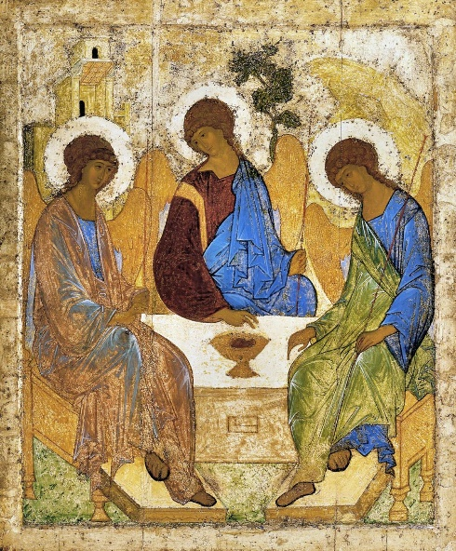 | Morning Worship  June 2020  Trinity Sunday

Morning Worship will be celebrating Trinity Sunday. Join us on the St Nicholas, Allington Facebook Group and also on our website at https://stnicholasallington.org.uk/
We reflect on what Trinity Sunday means to us at this time. We invite you to use the readings, reflections and prayers as part of a time of contemplation.
What is Trinity Sunday? When we gather for worship, we are celebrating all that God is and all that God has done. We are drawn into the life of the Trinity: the Father, Son and Holy Spirit. In John 14: 15-26, Jesus tells his disciples that we find God though him – the Son of God – but when the world no longer sees Jesus, the Holy Spirit remains to reminds us of all that Christ had said. Trinity Sunday is our celebration of this promise from God.
We look forward to the time when we will all be back together in person.
Ruth, Margaret, Mike and Nigel.

OPENING PRAYER (Collect for Trinity Sunday)
Holy God, faithful and unchanging:
enlarge our minds with the knowledge of your truth,
and draw us more deeply into the mystery of your love,
that we may truly worship you,
Father, Son and Holy Spirit,
one God, now and forever. Amen.

CONFESSION PRAYER
For the times we are slow to follow the example of Christ.
Lord, have mercy.
For the times we fail to be known as Christ’s disciples.
Christ, have mercy.
For the times we fail to walk the way of the cross.
Lord, have mercy.

READING - 2 Corinthians 13:11-14 (New International Version (NIV))
Final Greetings
¹¹ Finally, brothers and sisters, rejoice! Strive for full restoration, encourage one another, be of one mind, live in peace. And the God of love and peace will be with you.
¹² Greet one another with a holy kiss. ¹³ All God’s people here send their greetings.
¹⁴ May the grace of the Lord Jesus Christ, and the love of God, and the fellowship of the Holy Spirit be with you all.

READING - Matthew 28:16-20 ((New International Version (NIV)).
The Great Commission
¹⁶ Then the eleven disciples went to Galilee, to the mountain where Jesus had told them to go. ¹⁷ When they saw him, they worshiped him; but some doubted. ¹⁸ Then Jesus came to them and said, “All authority in heaven and on earth has been given to me. ¹⁹ Therefore go and make disciples of all nations, baptizing them in the name of the Father and of the Son and of the Holy Spirit, ²⁰ and teaching them to obey everything I have commanded you. And surely I am with you always, to the very end of the age.”

REFLECTION –
The reading from Corinthians portrays a Church that is one but separated. Paul set up churches throughout his missionary journey’s and then left them in the care of elders to carry on in faith. Paul expectation was that even though he was not there the church would continue and grow. By the time Paul had finished his missionary journeys there were lots of churches, separated by their geographical location but all together in faith of Christ. We learn from accounts in Acts that Paul established ways to keep communication going between Paul, his disciples, and the church communities to ensure they remained connected. Just as we have established ways to keep connected.
Paul would occasionally return to a church he had set up – just as we will return to worship together again.
Once the lockdown has eased and our church building may be open again, there are likely to be people who may not be able to attend physically due to shielding, even though our church building may reopen in some form for worship together, but we will remain together in Christ. We must also give thanks for all the new ways we have learnt to stay connected and have been able to welcome the new people we have connected with during lockdown. These things we should keep doing.
The last verse of the reading from 2 Corinthians encompasses the very nature of the Trinity. We repeat these words at the end of our Morning Worship service. Words of farewell but also anticipation that although we have gone our separate ways we are still together through God, Christ and the Holy Spirit.
Last week, Pentecost, we celebrated the fulfilment of Christ’s promise to send the Hold Spirit to remind us of everything that Christ had taught the disciples about God. In the reading from Matthew this week, the disciples are being sent out to carry on the mission in “the name of the Father, of the Son and of the Holy Spirit” – the Holy Trinity.
The Trinity, the well-known work by medieval Russian painter Andrei Rublev, portrays the three angels who visited Abraham and Sarah in Genesis 18.1-8. However, it is also interpreted with having the symbols depicting the Holy Trinity – the angel on the left represents God the Father, the angel on the left represents Jesus Christ, and the angel on the right represents the Holy Spirit. The position of each angel body creates a circle so as you look on the picture your gaze does not stay on one angel but rests in the space between them.
The wall hangings behind the altar in our church building are also a representation of the Trinity. God – represented by Alpha and Omega on the left-hand panel, the Son represented by the Cross on the centre panel, and on the right-hand panel there are the symbols of the Holy Spirit in fire and wind. Each panel is bound to the other with the grape vine, the bands of colour (blue representing water and green representing the land). Three in One.

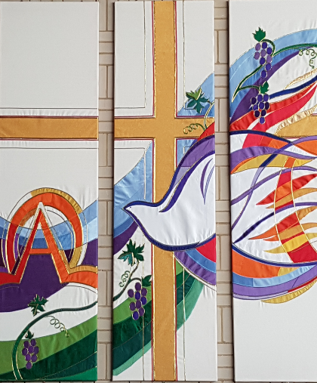

Take a moment to look at the picture of our wall hangings. Reflect on each of the three panels. Imagine basking in God’s eternal love. Ask Jesus to bring peace into any parts of your lives, or those of others, where you or they feel troubled. Reflect on how the Holy Spirit guides you and reminds you of Christ’s presence in your life.
In the reading from Matthew, Jesus said “be sure of this: I am with you always”. Whatever we do this week, through the Holy Trinity we can be confident of Christ’s presence.

PRAYER
We are not people of fear:
we are people of courage.
We are not people who protect our own safety:
we are people who protect our neighbours’ safety.
We are not people of greed:
we are people of generosity.
We are your people God,
giving and loving,
wherever we are,
whatever it costs
For as long as it takes
wherever you call us.
(Prayer by - Barbara Glasson, President of the Methodist Conference)
Keep us, good Lord,
under the shadow of your mercy.
Sustain and support the anxious,
be with those who care for the sick,
and lift up all who are brought low;
that we may find comfort
knowing that nothing can separate us from your love
in Christ Jesus our Lord.
Amen.

THE LORD’S PRAYER
Our Father in heaven, hallowed be your name.
Your Kingdom come, your will be done, on earth as in heaven.
Give us today our daily bread.
Forgive us our sins, as we forgive those who sin against us.
Lead us not into temptation but deliver us from evil.
For the kingdom, the power and the glory are yours.
Now and for ever. Amen

THE GRACE
May the grace of our Lord Jesus Christ,
And the love of God,
And the fellowship of the Holy Spirit be with us all, now and evermore.
Amen.

