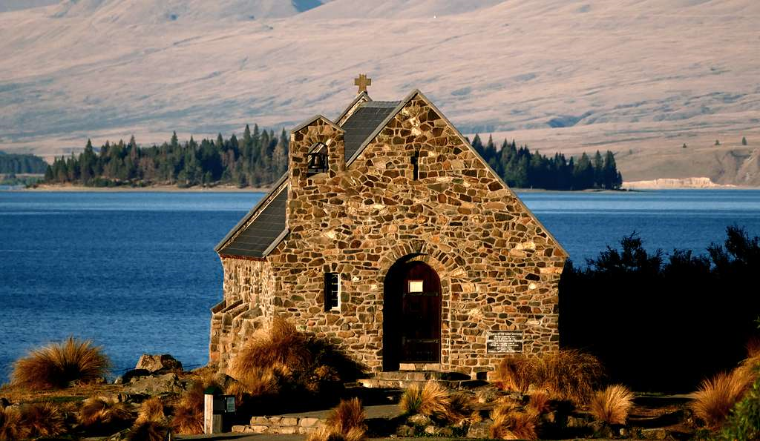 | Morning Worship  May 2020  The Good Shepherd

We cannot share this service with you as normal at Morning Worship but we invite you to read through what we had planned. The picture above is the Church of the Good Shepherd on the banks of Lake Tekapo in New Zealand. It reminds us of gathering together to worship – and what a wonderful place for worship. Sadly, we are unable to do this at the moment as we are in lockdown but there will come a time when we will gather again. This Sunday is Good Shepherd Sunday when we focus of Jesus who is the Good Shepherd who will lead us through the difficulties of our lives.
We will share the readings and prayers together on Facebook Livestream at 10am on Sunday but we also invite you to use the readings, reflections and prayers as part of a time of contemplation. Find a quiet place to sit inside or outside to do this.
We look forward to the time when we will all be back together in person.
Ruth, Margaret, Mike and Nigel.

OPENING PRAYER
Let us praise God together, we are one.
Let us praise God together, we are one.
We one as we stand with our faces to the risen Son.
O Lord, have mercy on us.

CONFESSION PRAYER
For the times we are slow to follow the example of Christ.
Lord, have mercy.
For the times we fail to be known as Christ’s disciples.
Christ, have mercy.
For the times we fail to walk the way of the cross.
Lord, have mercy.

READING - Acts 2. 42 -47.
The Believers Form a Community
⁴² All the believers devoted themselves to the apostles’ teaching, and to fellowship, and to sharing in meals (including the Lord’s Supper), and to prayer. ⁴³ A deep sense of awe came over them all, and the apostles performed many miraculous signs and wonders. ⁴⁴ And all the believers met together in one place and shared everything they had. ⁴⁵ They sold their property and possessions and shared the money with those in need. ⁴⁶ They worshiped together at the Temple each day, met in homes for the Lord’s Supper, and shared their meals with great joy and generosity— ⁴⁷ all the while praising God and enjoying the goodwill of all the people. And each day the Lord added to their fellowship those who were being saved.

REFLECTION – This reading tells of the time when Christians were gathering, to form the new church – the new creation that Jesus had spoken about. It was a huge time of change for them but one that we associate with good and exciting times, although it was also a time of persecution for them and so they may have felt a sense of confusion and worry about the future. At our current time it is perhaps difficult to feel the sense of “awe and wonder” felt by those early Christians and we are unable to worship together and physically meet but there are so many examples of sharing and being one community. Reflect on how has this time affected people? While separating us out has it in fact brought (some) people closer together? How has this time affected you? Who has reached out to you? Who have you reached out to? While we cannot share food and other things we are able to share…what are they…? A chat? A friendly greeting? An unexpected phone call? A re-connection with someone from the past? Happy memories? Plans for the future?

PRAYER –
Lord help me to look at my own life, seeing it in the context of my church fellowship, and help me to take a further step in walking with you today.

READING - Psalm 23.
¹ The Lord is my shepherd;
I have all that I need.
² He lets me rest in green meadows;
he leads me beside peaceful streams.
³ He renews my strength.
He guides me along right paths,
bringing honour to his name.
⁴ Even when I walk
through the darkest valley,
I will not be afraid,
for you are close beside me.
Your rod and your staff
protect and comfort me.
⁵ You prepare a feast for me
in the presence of my enemies.
You honour me by anointing my head with oil.
My cup overflows with blessings.
⁶ Surely your goodness and unfailing love will pursue me
all the days of my life,
and I will live in the house of the Lord
forever.
REFLECTION – Today is “Good Shepherd Sunday”. The Gospel reading for today is John 10. 1-10. Christ is the Good Shepherd. Reflect on verse 1. Spend time reading this a couple of times. The Lord, as a leader…not as in satisfying eating requirements, and security, but more as in leading us to “good places”. Maybe this is a time to experience solitude, as opposed to loneliness. Solitude being where we are just ourselves, no one to respond to ..to react to…to impress…or to entertain…just ourselves , with God . (or the Holy Spirit?)

PRAYER –
The Lord is my shepherd, I have all that I need. Lord, let your voice continue to speak and let my heart continue to listen, love and obey. Lead me and renew me.

CLOSING THOUGHTS
At the current time we are in isolation from each other and it is a time when we may have a sense of being alone and apart. The words of Psalm 23 have a sense of what it is to be isolated but words reassure us that Christ is still there to renew our strength and to guide us. At this time we can perhaps focus on the togetherness of the those words in the last verse – “I will live in the house of the Lord forever”. If you read the words of the hymn “The church is one foundation” (Songs of Fellowship 525) there is a sense of a church that is separated but still as one in Christ. One of the positives of the current situation is the way in which people have found ways to be together “virtually”. Social media and new technology that has often been a source of cyberbullying, fake news and scams has been successful in developing new and fresh ways of staying in contact, sharing and education. However, not everyone can access these things. So perhaps our mission for the future is to find ways of extending access for people within our community to encounter Christ through new technology and recreate the sense in the passage today from Acts within the 21st Century.
PRAYER -
We are not people of fear:
we are people of courage.
We are not people who protect our own safety:
we are people who protect our neighbours’ safety.
We are not people of greed:
we are people of generosity.
We are your people God,
giving and loving,
wherever we are,
whatever it costs
For as long as it takes
wherever you call us.
(Prayer by - Barbara Glasson, President of the Methodist Conference)
THE LORD’S PRAYER
Our Father in heaven, hallowed be your name.
Your Kingdom come, your will be done, on earth as in heaven.
Give us today our daily bread.
Forgive us our sins, as we forgive those who sin against us.
Lead us not into temptation but deliver us from evil.
For the kingdom, the power and the glory are yours.
Now and for ever. Amen

THE GRACE
May the grace of our Lord Jesus Christ,
And the love of God,
And the fellowship of the Holy Spirit be with us all, now and evermore.
Amen.

